1a) i)

I) Remove underexposed/overexposed -> 2, 11, 49, 223

2) Normalise -> (2/255), (11/255), (49/255), (223/255)

3) Invert gamma -> (2/255)^(1/2.2), (11/255)^(1/2.2), (49/255)^(1/2.2), (223/255)^(1/2.2)

ii)

1 stop apart -> 0.017255, (0.239595364)/2, (0.472486109)/4, (0.940869524)/8

= 0.11039513, 0.119797682, 0.118121527, 0.117608691

4 pixel values so weight by ¼ and sum

= 0.116480757

iii) Fish-eye lens Needs to be calibrated for fall-off in light towards periphery; sensors further from the center of the lens are less efficient at light capture than sensors closer to the center, so before inverting the response function, we must rescale based on fall-off function.

How reflective the mirror ball is, affects accuracy of captured light.

b)i)

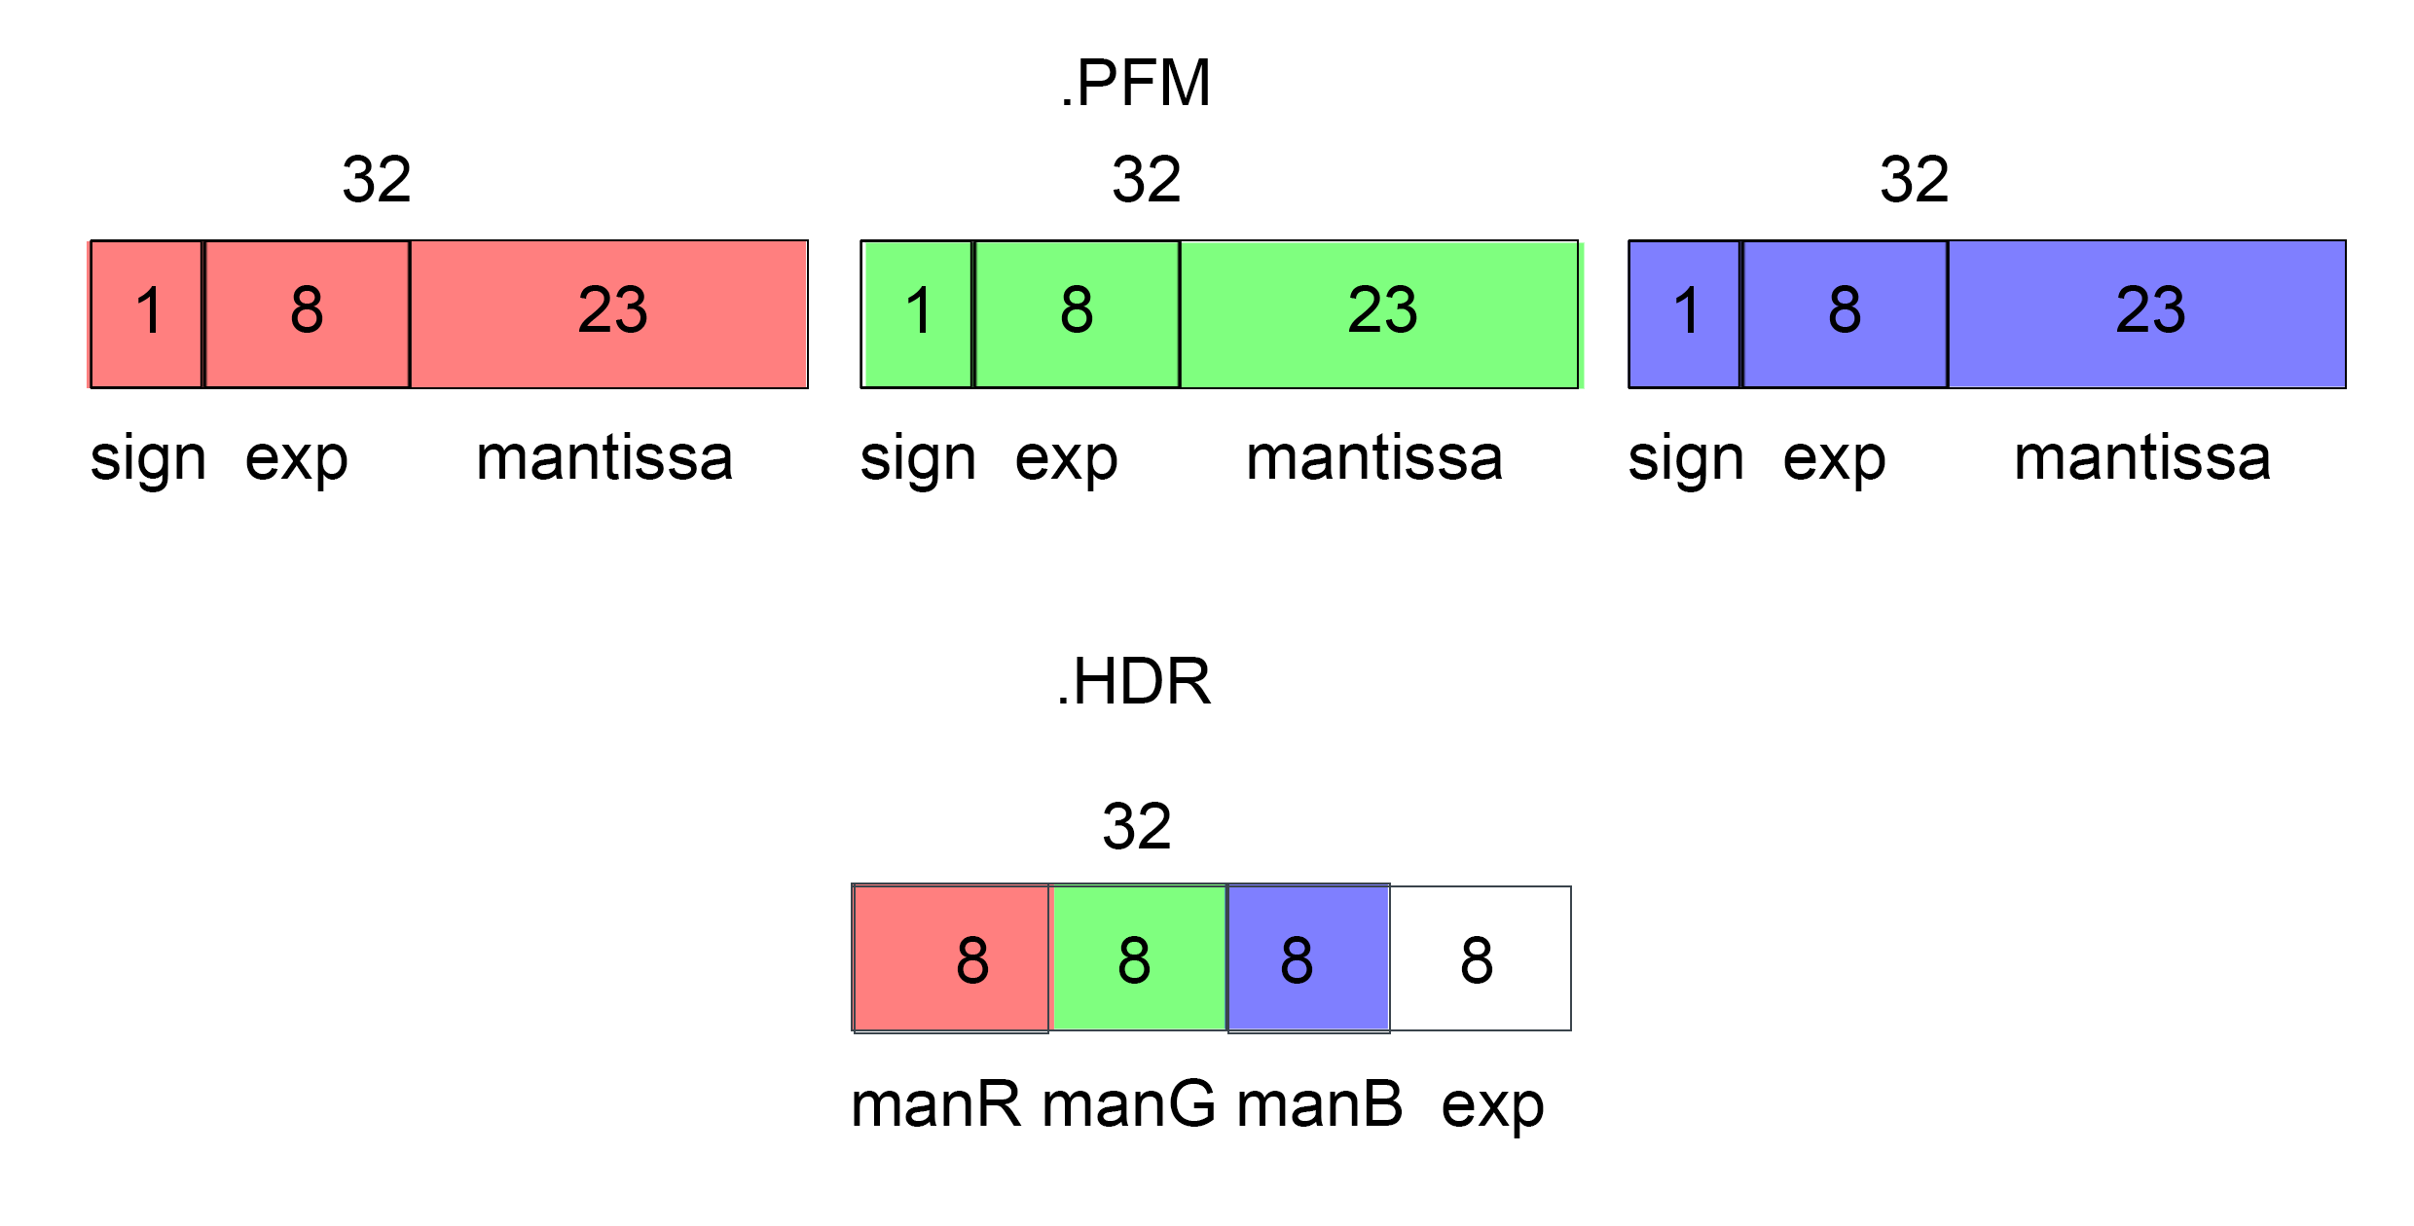

PFM

96 bits in total.

HDR

32 bits in total. It is reduced by:  
1. exponent is shared between the 3 channels. There is typically a high correlation between channel intensities, so all channels can be scaled by same exponent.

2. removal of sign bit. We expect intensities to always be positive as it is a representation of light. The sign bit is unnecessary

3. Reduction of per-channel mantissa from 23 to 8 bits. We instead offload the representation of intensity magnitude to the exponent, which now represents an exponential (* 2^(e-128)) rather than linear (* e) scale and can hence recreate large and small floating point values.

ii) A 4D light field is a ray based representation of a scene. 4D when rays are travelling through free space. Parameterised by two planes, a uv plane which is the viewing plane where you observe the scene from and the st plane which describes the scene itself. All the things you want to view exist in the st plane and all the viewpoints you want to view from exist in the uv plane.

iii)

Dual photography takes advantage of Hermholtz’s reciprocity of light transport, A = alpha B and B = alpha A, where A is the photodiode position, B is the light position and alpha is a constant transport quantity. AKA, the light seen by the photodiode is the same, even if photodiode and light swap positions. This means given a stack of real responses T, we can create a virtual image p’’ through converting a primal configuration to a dual configuration p’’ = T^T

T is created through stacked c’s, where c’ is the response of the photodiode when one pixel of the projector is turned on. To obtain this, we can illuminate the screen of a projector one pixel at a time, and a single photodiode to take the resultant MxN pixels. We can take the transpose of the light transport matrix, T^T, to create a virtual image as if the photodiode was the projector and the projector was the photodiode.

C) I)

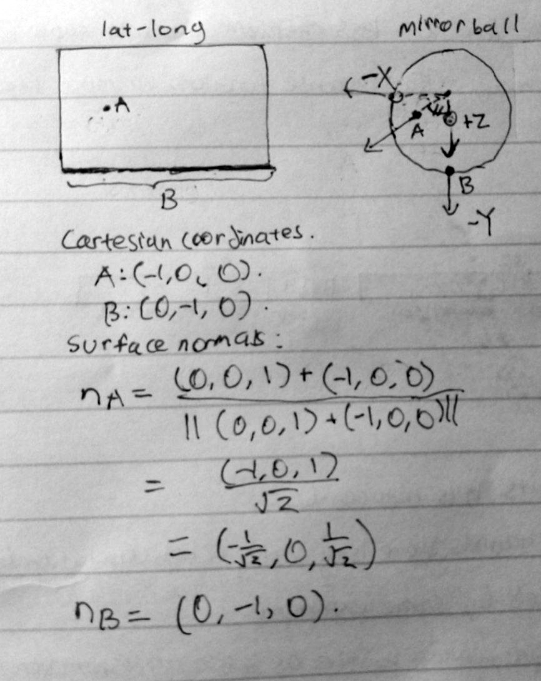

ii)

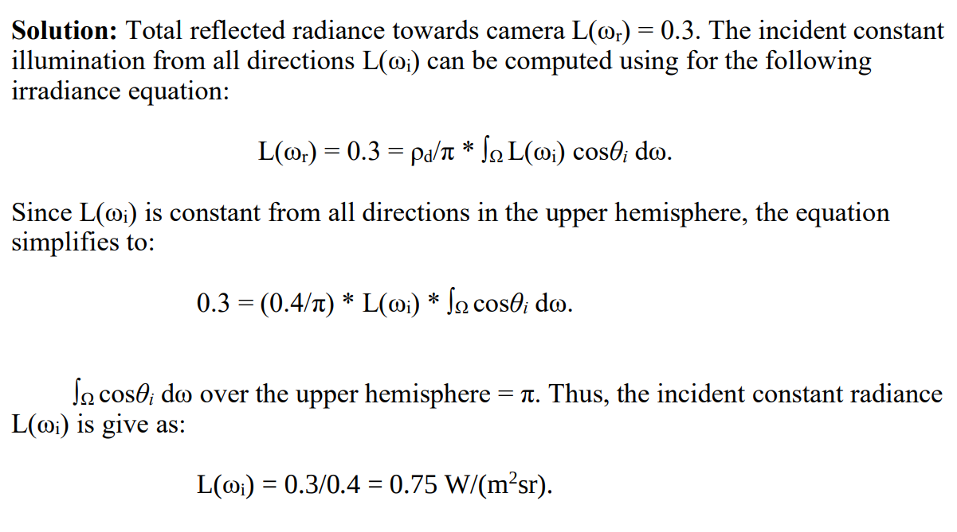

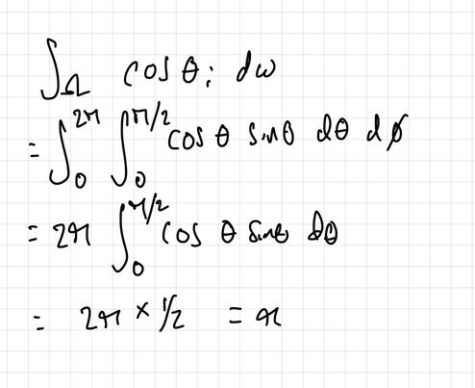

D) I) Image based lighting - Illuminating CG Objects using measurements of real light.

Image based lighting reproduction - IBR relights real subjects or objects whose reflectance field has been acquired using a light stage.

ii) RGB illumination has gaps in the spectrum, in contrast to skin on human faces, that have a more continuous reflectance spectrum. This creates visible differences in lighting reproduction compared to a photograph, as a composition of just R, G and B and responses is not an accurate reflection of skin response to orange and cyan energy. Spectral reproduction adds cyan, amber and white LEDs to RGB illumination to fill out the gaps, and consequently better sample the skin reflectance spectrum.

Iii) 250 * 20 = 5000 so 5000x5000 main sensor resolution and 250x250 micro-lens array

2)

A) I)



ii)

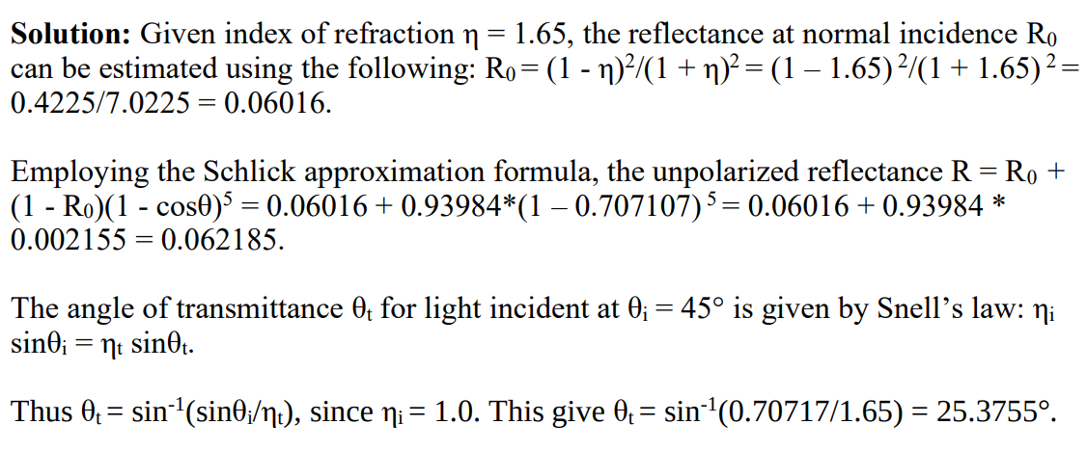

B) I) Both the structure of the physically-based and data-driven microfacet models are the same, a formula that models the reflectance of a surface through the interaction of incoming light with a collection of microfacets:

BRDF: fr(wr, wi) = (D G F) / (4 (n.wi)(n.wr))

The difference is that the physically-based model solves for D, G, F through other mathematical calculations based on assumed properties of the underlying medium. Meanwhile, the data-driven model takes measured values and fits them to a D, G, F that would most accurately reflect these values.

Ii) Instead of using omega_I and omega_o, you use a half vector omega_h and omega_d which is the difference between the illumination direction and the half vector. The specular highlights become symmetric about the half vector and the BRDF matrix simplifies to a lower rank matrix. Goes from a full rank matrix to a 1 rank matrix as there’s only variation in the omega_h direction. Allows you to do non linear sampling along the omega_h axis.

Iii) Satin reflects light in the mirror reflection direction anisotropically. Velvet reflects light most strongly in the back scattering/retro reflective direction. Velvet has bright isotropic highlights only at grazing angle.

C) i) Examples in the slides.

ii)

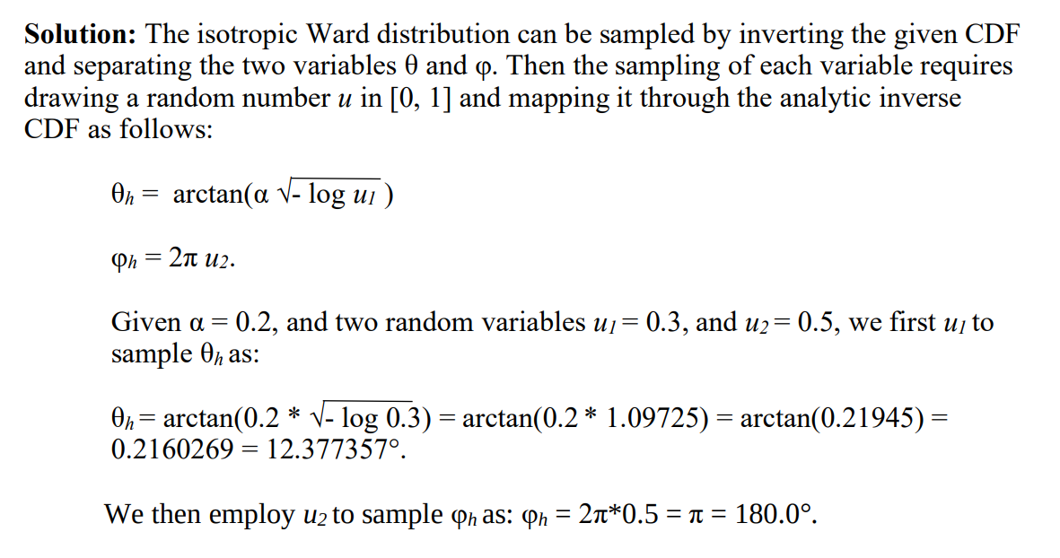

D) i) Catadioptric systems typically use some sort of mirror/camera system. Some use concave or convex mirrors and others use a hemispherical mirror. Another design uses a cylindrical mirror and points the camera towards the sample but has this mirror in between. Depending on the angles of incidence, different angles of reflection will be created and each one creates a different radial line.

Speeds up measurements by allowing you to capture the results of various angles of incidence in a single photograph.

Ii) point is quadratic, linear and spherical are linear:

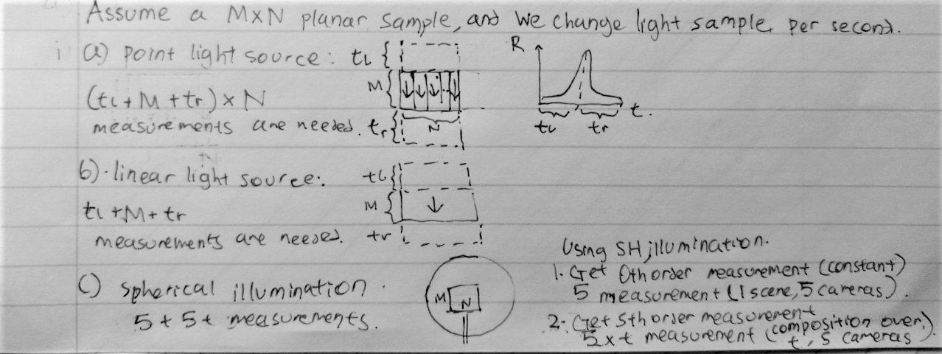point light sources have the highest dynamic range, followed by linear light and then spherical illumination. Point light sources create sharp specular lobes, which are more spread out across the surface in linear light, and even more so in spherical illumination. This is because light is coming from more directions, across a larger area.

3)

a) Sum each row and you get 100, 100, 100, 100.

Pdf = 0.25, 0.25, 0.25, 0.25

Cdf = 0.25, 0.5, 0.75, 1

Indexes start at 1 from top left

Row 1 -

Pdf = 0.05, 0.25, 0.35, 0.15, 0.2

Cdf = 0.05, 0.3, 0.65, 0.8, 1.0

Row 2 -

Pdf = 0.1, 0.2, 0.3, 0.25, 0.15

Cdf = 0.1, 0.3, 0.6, 0.85, 1.0

Row 3 -

Pdf = 0.3, 0.1, 0.05, 0.2, 0.35

Cdf = 0.3, 0.4, 0.45, 0.65, 1.0

Row 4 -

Pdf = 0.25, 0.2, 0.1, 0.35, 0.1

Cdf = 0.25, 0.45, 0.55, 0.9, 1.0

i) Row 3, col 3 => 5

ii) Row 1, col 4 => 15

iii) Row 4, col 2 => 20

iv) Row 2, col 3 => 30

v) Monte carlo is correct but has high variance. Median cut is consistent and deterministic but biased

B)

i)

Similarity:

Both irradiance caching and photon mapping use a 2-pass algorithm, that in the first pass stores some representation of energy, and in the second pass locally interpolates this stored energy to generate new samples, to make more efficient rendering computations.

Difference:

Irradiance caching stores irradiance samples in an octree in the first pass, whereas photon mapping stores photons in a balanced kd-tree. Irradiance samples in the same octree cell are combined in a weighted interpolation per sample in that octree cell, whereas photon mapping takes a weighted interpolation of photons in the radial neighborhood of the sample.

ii) 3rd bounce – 0.3 * 0.3 * 0.7 = 0.063

4th bounce – 0.3 * 0.3 * 0.3 * 0.7 = 0.0189

iii) (0.7 * 0.4) / (0.3 * 0.6) = 1.5556 so min(1, 1.5556) = 1

C)

i) Use formula from tutorial 5 and you get –0.3

Ii) 850 * (0.45/pi) * (0.25/pi *(0.4)^2) = 60.555 w/m^2sr

D) i) Derivation in lecture 16, slide 40

ii)

The spectral model is based on 2 layers of skin. It models epidermis and dermis absorption. It is based on the bio-physical parameters of melanin and haemoglobin concentrations in skin.

A multilayer diffusion model is used for the various layers of skin.

**we can model the epidermis using the multipole model, as it is the thinner layer, and the dermis can be modelled using the dipole method.